SCHEDULE OF FEES
All Fees Subject to Change

SAVINGS ACCOUNT FEES

Dormant Account, per month $5.00
(Over age 18, no activity 12 months, savings less than $200.)
Early Closing, under 90 days
Age 18 or over $20.00
Under age 18 $3.00
IRA Unqualified Withdrawal, per withdrawal $25.00

CHECKING ACCOUNT FEES

*Automatic Transfer/Withdrawal Limit, from savings
Seven or more, per transfer $2.00
Counter Checks, per 12 $6.00
Custom Checks, per style Varies
Notice of Transfer, per transfer $2.00
From loan to cover overdraft
NSF Returned, per item-business & personal $34.00
(Check or ACH Debit)
NSF Paid, per item- business & personal.. $34.00
(Check, POS or ACH Debit)

“Paid” Non-Sufficient Funds (NSF) item(s) up to $500 negative
balance. (This service will only be available to members who
meet eligibility requirements.)

Fees will be assessed to any share or checking account
business or personal, which may result in a negative balance.

*Federal Regulation D Requirements: For all savings, Club, and Money Market
accounts, you may make no more than six (6) transfers and withdrawals from
your account to another account of yours or to a third party in any month by
means of a preauthorized, automatic or internet transfer, by telephonic order or
instruction, or by check, draft, debit card or similar order. If you exceed these
limitations, your account may be subject to a fee or be closed.

Fees effective March 11, 2016 and subject to change. 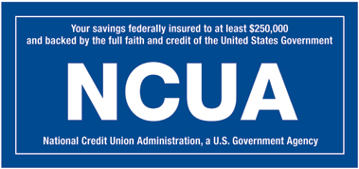 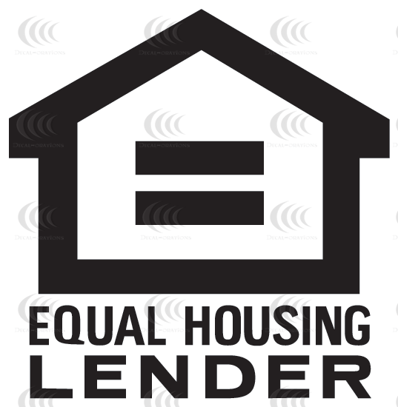

ATM FEES

ATM Deposits & Inquiries No fee
ATM Withdrawals
Northern Hills Federal ATMs or CO-OP Network ATMs
First 10 withdrawals per month No Fee
11 & higher withdrawals, each $1.50
Out of Network ATM Withdrawals, each $1.50
Replacement ATM/Debit Card $5.00
International Transaction, per transaction 1%
ATM/Debit/Checks Charged by clearing networks for currency
exchange

BUSINESS CHECKING ACCOUNT FEES

Service Fee, per month
Up to 100 items $5.00
101 to 300 items $25.00
301 or more items $50.00
Currency Orders, per order
Up to $500 Free
Over $500 $5.00
Coin Orders, per order
Up to $100 Free
Each additional $100 ordered $1.00
Coin Counting Free
Business Debit Card Free
EasyPay Free

- All other fees not listed will apply to Business Accounts.
- Monthly service fee based on total number of items deposited and clearing the account; including electronic transactions.
- An annual review of all Business Checking Accounts will be conduct to determine proper tier.
- Organizations are exempt from monthly service fee.

OTHER FEES

Account Research/Reconciliation, per hour $20.00
(1 hour minimum -plus costs)
Business Deposit Books $8.50
Cashier's Check, per check $5.00
Check Cashing, per check $5.00
(When age 18 or over AND checks total $50 or more, unless
$200 in savings or with current loan)
Check Lookup/Copy, per item $5.00
Coin Counting, Free
Non-members 6% of total
Collection Item, in/out plus costs $10.00
Easy Pay - Bill Payment & Presentment Free
Transaction Research, each $25.00
*Refer to agreement – special charges may apply for stop
payments, etc
Escheat Fee $25.00
Fax International - Sending
First page $10.00
Each additional page $5.00
Fax – Receiving, per page $1.00
Fax – Sending, per page Local or 800 $1.00
Domestic first page $3.00
Domestic each additional page $1.00
Foreign Item Exchange Check US Funds
…see collection item
Guaranteed Funds Check, per check $15.00
HSA Debit Card $5.00
HSA Account Closure $25.00
Incorrect Address/Returned Mail, per piece $3.00
Legal Processing, costs plus minimum of $15.00
(Levies, garnishments, executions, etc.)
Loan Extension $35.00
Loan Subsequent Action $35.00
(Change collateral, comaker etc)
Loan Title Handling, per item
South Dakota $10.00
Out of State $35.00
Long Distance Call, per call to verify funds $3.00
Mail Receipt $2.00
Money Orders, $1,000 maximum $1.50
Money Zipper Bags, large $5.00
Money Zipper Bags, small $2.00

NHFCU Check
Issued to member No fee
Issue to third party $3.00
Notary Service No fee
Photocopy, per page $.25
Returned Item, per time returned
Check written by Member $40.00
Check written by Non-member $10.00
(Dishonored check)
ACH Origination Item $40.00
(Loan or deposit)
Statement History Printout, per month $5.00
History 3 years & older, per month $10.00
Stop Payment, per item $25.00
(Electronic or paper – to place or remove)
Verification of Deposit $10.00
VISA Reloadable Prepaid Cards, per card $5.00
Personalized card, per card $10.00
Card reload, per time $2.00
Online reload using NHFCU Debit Card $1.25
(Fee and reload amount shows as one debit card transaction)
Wire Transfer – Domestic
Incoming, per wire $5.00
Outgoing, per wire $20.00
Wire Transfer – International
Outgoing, per wire $50.00

ANNUAL SAFE DEPOSIT BOX FEES
(Sturgis Office)

3 x 5, per box $15.00
3 x 10, per box $25.00
5 x 10, per box $35.00
Key Deposit, 2 keys, refundable $25.00
Key Replacement, per key $10.00
Late Payment of Annual Rental $5.00
Replacement Lock, one lost key $45.00
Unclaimed Property $75.00
Drill Safe Deposit Box, two lost keys $250.00

H drive/MemberServices/MbrDisclosures/FeeSchedule Mar 2016

